

SEND policy
  - June 2026

Policy Type: | HCC/HfL/School
Review schedule: | Annual
Target audience: | Staff, pupils, parents, governors.
Summary:

Mission
To provide an exciting, ambitious and unique early education for all

Values
- Respect: Accepting yourself and others for who they are
- Ambition: A desire to achieve your best
- Perseverance: To keep going in spite of obstacles

We respect our pupils as individuals and along with our school community share high ambitions for them. Developing their perseverance so that in spite of future obstacles they can continue to be their best self and develop their love of learning.

Page 3 – Guiding principles
Contents
Page 3 – Identifying SEND
Page 4 – Objectives
Page 5 – A graduated approach to SEND support
Page 7 – Monitoring and Evaluating SEND
Page 8 – Storing and Managing Information
Page 9 – Provision Maps
Page 12 - Supporting Pupils with Medical Conditions
Page 12 – Partnerships
Page 14 – Staff development
Page 15 – Resources
Page 15 – Accessibility
Page 16 – Admissions and Transition
Page 17 - Equal Opportunities, Terminology and Imagery and Bullying
Page 17 – Dealing with complaints
Page 19 – Appendices

At Fawbert and Barnard we ensure that all children know how valued and unique they are, regardless of their ability or need. We recognise that all children are entitled to a broad and balanced curriculum that must be differentiated to meet their individual needs. We focus on the concept of equity over equality, with our approach to Special Educational Needs and Disabilities (SEND) based on the needs of each individual child.

Guiding Principles
As a school, our mission is to provide an exciting, ambitious and unique early education for every child. Individuals are encouraged and inspired to develop a love of learning in their own unique way.
Leaders, Teachers and Support Staff work collaboratively to identify and provide support for pupils with SEND, as it is our belief that all educational professionals contribute to a child’s learning journey. All teachers are teachers of all children including those with SEND.
This policy complies with the statutory requirements laid out in the SEND Code of Practice (January 2015) and has been written with reference to the following guidance and documents:
- Equality Act 2010: Advice for Schools DfE Feb 2013
- SEND Code of Practice 0 – 25 (January 2015)
- Schools SEND Information Report Regulations (2014)
- Equality Act 2010: Advice for schools DfE Feb 2013
- Statutory Guidance on Supporting pupils at school with medical conditions (April 2014)
- The National Curriculum in England Key Stage 1 and 2 Framework Document
- Fawbert and Barnard Infants School Policies and Documents: Safeguarding, Accessibility Plan, SEND Information Report, Whole School Provision Map.
- DfE Teachers Standards

Identifying SEND

According to the SEND Code of Practice (2015): “A child or young person has SEN if they have a learning difficulty which calls for special educational provision to be made for him or her… or if they have a significantly greater difficulty in learning than the majority of others of the same age or has a disability which prevents or hinders him or her from making use of the facilities of a kind generally provided for others of the same age in mainstream schools”.
The Code of Practice identifies 4 broad areas of need:
- Communication and Interaction
Communication and Interaction conditions may include children who have speech, language and communication needs and / or autism.
This may present as a child: having difficulty in communicating with others, having difficulty saying what they want to, or having difficulty understanding what is being said to them. The child may be delayed in using language and shy away from talking.
- Cognition and Learning
Cognition and Learning difficulties affect a child’s ability to learn and achieve at school. Specific Learning Difficulties (SpLD) include a range of conditions such as Dyspraxia, Dyslexia and Dyscalculia. Children who have needs in one or more of these areas are classed as having ‘Complex Needs’. They may also be described as having ‘mild’ or ‘severe’ learning difficulties depending on the degree of need and how this affects their daily life.
Support for pupils with learning difficulties is needed when a pupil is learning at a slower pace than their peers are.
- Social, Emotional and Mental Health
Pupils experiencing social, emotional, and mental health difficulties may present as withdrawn or isolated, hyperactive or lack concentration, immature in relation to social skills, displaying behaviour that challenges which could be masking other complex needs. They may be frustrated and struggle with school routines, boundaries, and relationships.
Pupils may suffer from difficulties such as anxiety or depression, or they may have disorders such as attention deficit disorder (ADD), attention deficit hyperactivity disorder (ADHD), or attachment disorder.
- Sensory and / or Physical
Children with sensory or physical needs may have a disability, such as physical disability, visual impairment, hearing impairment, multi-sensory impairment (both hearing and vision difficulties), and dyspraxia. They may need specialist equipment to support them with their learning and could need help with daily tasks such as eating or travelling.
The Hertfordshire Local Offer states that Special Educational Needs ‘can affect a child or young persons: ability to learn, behaviour or ability to socialise and make friends, reading and writing, ability to understand things, concentration levels, physical ability’. It identifies SEND provision as ‘help that is additional or different from the support generally given to other children or young people of the same age’.
At Fawbert and Barnard Infants School, we monitor all pupils through a variety of ways to identify those working below the expected level for their age and individual circumstances. It may be the case that rather than one primary need, a child has a need that goes across more than one of the above areas, or changes and evolves over time. This is why we focus on a detailed and highly personalised assessment process that ensures all ranges of a child’s individual needs are identified.

Objectives

- To ensure the SEND and Disability Act and Relevant Codes of Practice and guidance are implemented effectively across the school;
- To provide all children with SEND with access to a broad and balanced curriculum, through quality first teaching;
- To provide high quality training, support, and advice for all staff to enable them to deliver high quality first teaching for all pupils;
- To provide a non-class-based Inclusion Lead to facilitate SEND/ Inclusion across the school,
ensuring a whole school approach to the provision of support for pupils with additional needs and vulnerable groups.
- To ensure equal opportunities for children with special educational needs;
- To create or source rigorous assessment and monitoring processes to identify specific needs for children with SEND, using these to provide the most effective strategies and interventions to ensure they reach their full potential;
- To be transparent with parents, involving them in every stage of their child’s journey;
- To always ensure that decisions and actions made place the child at the centre, involving them in their learning journey;
- To work collaboratively with external agencies, using recommendations to support the needs of individual children.

A graduated approach to SEN Support
A graduated approach to SEND support
At Fawbert and Barnard Infants, we use a Graduated Approach to support children with SEND.
Assess: An accurate assessment of the pupil’s needs is obtained through observation, professional dialogue, and data. This identifies pupils who are not progressing in line with their expected levels and who may have additional needs.
Poor progress is characterised as progress which:
- is significantly slower than that of their peers starting from the same baseline;
- fails to match or improve on the child’s previous rate of progress;
- does not close the attainment gap between the child and their peers;
- widens the attainment gap (Special Educational Needs Code of Practice 2015).

In addition to progress and assessment data, indicators that may signal a pupil needs additional support could include:
- a significant change in their behaviour;
- a concern(s) raised by an external agency (for example a GP or the school nurse);
- information obtained from a previous setting the child has attended;
- information presented by a parent or carer about their child’s needs;
- information presented by the pupil’s class teacher;
- observations by members of the teaching team.
Any concerns regarding a child’s progress, attainment, behaviour, or emotional wellbeing will result in a meeting between home and school (instigated by either parties) in order to discuss and voice concerns. At this meeting, it will be agreed upon by all involved if the concern is to be formalised and further steps put in place, or if at that moment in time no further action is required.
Plan: If ‘additional to and different from’ support is required, then the views of all involved, including the parents and the pupil, will be obtained. Evidence based provision and interventions will be devised.
Do: Provision and interventions will be implemented. The member of staff responsible for the delivery of this will vary, depending on the individual requirements, however overall accountability remains with the class teacher, supported by the Inclusion Lead.
Review: Progress towards these outcomes will be tracked and reviewed, and a new cycle amended and implemented (if required). Progress for children on the SEN Register is measured in a highly personalised way. Progress will take different forms and vary depending on the needs of the child. The expected progress will always be outlined as part of the APDR cycle.
This happens on a termly basis, where new targets are set, and the previous ones appraised. If there are achievements or further concerns that call for a review within a shorter period, these will be discussed with the parents and child at an appropriate time.
The provision of support offered at Fawbert and Barnard Infants follows a model as outlined below:
Universal: This is quality first teaching and strategies, which are used to support the learning and development of all children. For example, specific success criteria for a given task, appropriate use of teacher questioning, use of a variety of auditory, visual, and kinaesthetic teaching aids.
Targeted: These are additional strategies, which are used to support some children. These may be shorter term interventions with small groups of children, for example a social skills group or additional phonics recap group or 1:1 interventions for example a 5-minute spelling recap every day with the class teaching assistant.
The teaching team will monitor these children to ensure sufficient progress and specific interventions will be identified within their Provision Map (One Page Plan).
Specialist: These are additional and highly personalised interventions, usually focusing on fewer children. They often involve a child working with a member of the Inclusion Support Team and outside agencies such as Speech Therapists, Occupational Therapists or Outreach and Specialist Advisory Teachers. These children will be on the SEN register and have their own Individual Provision Plan.
Where needs are similar in Targeted and Specialist, it may be appropriate to support these children within a group, focusing on the common needs, however the child will still have individual targets if their needs are additional to those of other children in the class.
The responsibility for children with SEND remains with the class teacher at all times, but in consultation with the Inclusion Lead, to ensure targets and provision appropriately matches the needs of the child.

Monitoring and Evaluating SEND

The Governing Body: The Governing Body has overall responsibility for the school’s policy and approach to providing for children with SEND. They appoint a specific Governor to monitor this work in support of the children. At Fawbert and Barnard, there are SEND and Vulnerable Groups Governors who work closely with the Inclusion Lead and Senior Leadership team to:
- Remain informed about current developments within SEND;
- Develop and maintain awareness of the provision provided by Fawbert and Barnard on behalf of the Governing Body;
- Provide support and challenge to the Inclusion Lead to monitor SEND provision across the school;
The Head Teacher: The Headteacher has overall responsibility for the day-to-day management and provision for children with SEND, working closely with the Inclusion Lead to monitor SEND provision across the school.
The Inclusion Lead:
The Inclusion Lead is responsible for:
- Overseeing the day-to-day operation of this policy;
- Co-ordination of the specific provision in place to support individual pupils with SEND;
- Keeping records for children with SEND up to date;
- Providing professional guidance and support to colleagues on SEND;
- Leading on whole school SEND training;
- Monitoring and evaluating the progress of pupils with SEND alongside the Senior Leadership Team;
- Supporting staff with the assessment and individualised provision for those children not at age related expectations;
- Modelling best practice and teaching in relation to SEND;
- Carrying out assessment and observations of pupils with specific learning needs;
- Coaching classroom support staff in their approach to children with SEND;
- Ensuring that key information (aligning with confidentiality) is communicated across the staff body for pupils with individual needs;

- Participating in local authority briefings and DSPL groups;
- Working closely with professionals and outside agencies to ensure that pupils with SEND receive the best possible care;
- Liaising with Early Years providers, other schools, and potential next educational settings to ensure smooth transitions for children with SEND and their parents;
- Being mindful of the Hertfordshire Local Offer, ensuring that the school’s SEND Information Report is up to date and easily accessible.
The Class Teacher
The Class Teacher is responsible for:
- Making regular assessments, both formal and informal, which seek to identify children making less than expected progress, given their individual circumstances. This includes progress in areas other than attainment – for example where a pupil is not meeting the expected milestones in relation to their social needs;
- Utilising the chosen school assessment resources for those children not at age related expectations in order to set highly effective targets;
- Using high quality teaching to target areas of weakness and areas of development for pupils in their class;
- Engaging in professional dialogue with the Inclusion Lead and Leadership Team about the needs of pupils in their class;
- Ensuring all interventions for all pupils are recorded and tracked effectively in line with school documentation;
- Ensuring any communication in relation to a child’s individual need is shared with the relevant parties;
- Being open to support and guidance from both the Inclusion Lead, and other Outside Agencies, in order to seek the best approach for a pupil’s identified need;
- Deploying support staff effectively to meet the particular needs of pupils.

Support Staff:
Support Staff are responsible for:
- Working collaboratively with Class Teachers, the Inclusion Lead, the Senior Leadership team, and outside agencies, in order to enable both pupil access and progress;
- Supporting individuals or groups within the class as directed;
- Delivering agreed interventions and provision with small groups and individual children;
- Ensuring any communication in relation to a child’s individual need is shared with the relevant parties (usually the Class Teacher in the case of a support member of staff);

Storing and Managing Information

- All physical documents and information regarding children with SEND are kept securely within a pupil’s SEND file, which only certain members of the staff team have access to;
- Electronic files are kept on the school server secured computer storage system;
- Relevant information is recorded via Arbor, the schools central management system;
- Any document and information related to any child with SEND will only be shared with relevant staff. If there is no alternative but to share via email this will be done as a password protected document, with the password sent in a separate email to the document.
- When a pupil with SEND moves settings, their files are transferred securely, within 5 days of acknowledgement that they have joined their new setting.

Provision Maps

At Fawbert and Barnard Infants, Provision Maps take two approaches:
- Whole School Provision Map (Inclusion Offer) (Appendix 2)
This is an ‘at a glance’ document detailing the range of provision provided for children across the school. The Whole School Provision Map is split into three sections:
- Universal: This is universal support provided to all children. It is known as inclusive quality first teaching for all.
- Targeted: This section details additional interventions that could / may be offered to children. The targeted support is usually for a shorter, measurable period, for example half a term. It may be that a child has found a particular concept within the maths curriculum tricky and therefore receives half a terms intervention to bring their progress in line with other areas of their maths learning. Children receiving targeted support may be grouped together based on their needs; however, each will have their own target.
Children placed in this category will have a ‘One Page Provision Plan’ that outlines the provision and interventions they are in receipt of.
- Specialist: These are additional and highly personalised interventions provided to the child based on their identified specific needs.
Children placed in this category will have an Individual Provision Plan containing a thorough overview of their learning journey.

- One Page Provision Plan (Appendix 3)
One Page Provision Plans are working documents that identify the strategies being used to support individuals within the class. They are updated as and when the needs of the child changes and evolves. They can also be used as a chronology to show the level of support being received by a child, which may then lead to involvement from the Inclusion Lead (child being placed on the SEN Register) or external agencies dependant on progress.

Whilst the Class Teacher is responsible for the progress of all children in their class, the Inclusion Lead is also heavily involved in supporting the progress of children through quality assuring the One Page Provision Plans and providing guidance and support to colleagues.
A One Page Provision Plan is necessary for any child who is in receipt of support that staff consider being beyond the rest of the class. Children with a One Page Provision Plan will usually be on the SEN Monitoring List. This means they are discussed more regularly across the team to see how further support can be provided in order to help them get to where they need to be.
One Page Provision Plans are internal documents that are used to support continuity for the children – for example, a cover teacher entering the classroom is always given access to the One Page Provision Plans so they are aware of the children who require additional reading opportunities, or rest and movement breaks etc.

- Individual Provision Plans (IPP) (Appendix 4)

If SEND intervention on a formal level is necessary, then a child is placed on the SEND register and parents are notified. The creation of an Individual Provision Plan for the child would then take place, setting out specific targets to support the child.
A child’s Individual Provision Plan encompasses their overall learning journey, through the following sections:
Overview: Attendance, Adults & Outside Agencies Involved in the Child’s Learning, The Current Level of Support they are in receipt of (What Primary Need, whether additional adult support is required, whether the child is in receipt of funding), Additional Information (PPG, EAL, Medical Needs).
All About My Presenting Needs: Identified needs including category, how this presents and strategies that are used to support.
Assessment: An overview of where the child is working at in Reading, Writing, Maths and the Wider Curriculum (Speech & Language, PSED or other relevant areas). This is monitored from previous year exit across all 3 terms of the academic year.
My Goals and Progress: The specific areas that provision is focused on. What these areas are, how these will be supported and what success in these areas will look like.
Input from my Parent / Carers: Parent Voice.
Pupil Voice: Exploration of the pupils motivation (likes and dislikes, what I am good at, what is important to me), hopes and aspirations (when I am older…next term… next year..), what makes it hard for me to learn (specific things I find difficult), how I want to be supported (how adults can help me, how I can help myself, resources that support my learning). This is a separate document attached to the IPP. This is collected in a variety of ways, according to the needs of the child (e.g. use of talking mats).
Signatures: All stakeholders involved in a child’s journey will sign and receive a copy of their Individual Provision Plan.
The Individual Provision Plan is informed by data, observations, and professional dialogue.
These plans are initially created by the Inclusion Lead, involving the wishes and feelings of everyone that is part of the child’s educational journey. Following the first cycle, the class teacher then takes responsibility for updating the IPP and reviewing the previous one, with the Inclusion Lead maintaining a strategic approach.
The Inclusion Lead and Senior Leaders regularly monitor the progress of all children on the SEND register, and may suggest the involvement of external professionals if required.
Individual Provision Plans for known children follow a cyclical process across the academic year: September – IPP 1 Implemented
December – IPP 1 Evaluated
January - IPP 2 Implemented
March – IPP 2 Evaluated
April - IPP 3 Implemented
July – IPP 3 Evaluated and consideration made for targets for next academic year.
At each point above parents have the opportunity for an additional meeting with the Inclusion Lead (in addition to parent consultation evenings) to discuss their child’s progress.
Children’s needs and when they present will not all fall in line with the above dates and therefore run on an individual basis, with the yearly outline as a guide.

- Education Health and Care Plans
If after a period of support a child is continually not making adequate progress (expected for their individual circumstances), then the school, in agreement with the parents / carers, may request the local authority to make an Education, Health and Care needs assessment to decide whether it is necessary for provision to be made in accordance with an Education, Health and Care Plan (EHCP). For an EHC needs assessment, the school is required to submit evidence to the local authority (Hertfordshire or Essex depending on the child’s home address), and a judgement is made regarding whether the child’s needs can continue to be met from the resources normally available to the school. If a child receives an EHC Plan, then the necessary provision is made for the specialist support needed.
For a child with an EHC plan, there will be an Annual Review, chaired by the school and attended by all professionals involved in the care of the child. This meeting will review the appropriateness of the provision and the professionals involved in the care of the child will recommend to the local authority whether any changes need to be made to the Education Health Care Plan. If the needs of a child change dramatically over a short period of time, then the school may arrange an earlier review meeting to discuss whether the needs of the child can still be met at Fawbert and Barnard Infants School. Across Hertfordshire, any families wishing to obtain Specialist Provision must have their child’s case heard at Provision Panel. Panel takes place on a monthly basis, with specific documentation submitted to the child’s SEN Officer following a highly structured criteria.

Supporting Pupils with Medical Conditions (separate policy available)

All pupils with medical needs should be effectively supported so that they have full access to education, which includes school trips, enrichment activities and physical education. Some children with medical needs may have a disability, and where this is the case, the school complies with duties under the Equality Act 2010, ensuring that reasonable adjustments are made to remove barriers to learning so the child is fully included. On admission to school, parents are asked to identify any medical needs for their child, and if appropriate, a medical care plan will be made. However, for some children if their medical needs impact significantly on their learning they may have an Education Health and Care Plan to meet these needs.
It is the school’s responsibility to ensure that staff are suitably trained to meet the needs of children with medical conditions. Training will sometimes be provided for all staff (first aid), or specialist training for those staff working closely with individual children (e.g., those children with Diabetes where staff need further in-depth training in order to support the child).
All staff will be aware of the medical needs of pupils and children in school, identified via a pupil medical information sheet on display in the office, staff room and other relevant rooms. Where staff have specific responsibilities for the medical needs of a child, there are always plans in place to ensure that, in the case of staff absence, appropriate care is always available.
Needs of individuals will be identified within risk assessments for school trips, visits and activities that are outside the normal timetable. These will be made in conjunction with the child’s parent / carer to ensure that all areas of need are covered when attending a new environment with a different routine.

Partnerships

- With Pupils:
At Fawbert and Barnard Infants’ School, we take a child centred approach to all decisions. We believe all children have the right to be actively involved in making choices about their learning, and exercising their preferences, likes and dislikes. We strive all times to ensure that the child is involved in decisions about their learning in an age-appropriate way. Pupil Voice is at the heart of all policies, processes and approaches taken.

- With Parents and Carers:
At Fawbert and Barnard Infants’ we value greatly the views and opinions of parents and carers. They are actively encouraged to participate in the development of strategies to support their child both in school, and at home. We recognise the huge investment that all parents make in their child’s academic learning, and personal and emotional development, and aim to always respect their wishes and feelings, whilst being guided by the data and observations of professionals, to ensure that a child receives the best possible care. Parental permission is requested before the involvement of any outside agencies, with parents being kept up to date on the processes and outcomes. Whilst we fully understand the challenges faced by parents and empathise with each individual situation, we are also committed to showing transparency in our conversations, so that they can make the correct and most informed choice for their child’s education.
In relation to a particular SEND need a child has, the class teacher and Inclusion Leader, together with parents and carers, will utilise the family’s knowledge and expertise in relation to the child. Areas of strength, as well as those areas for development, are focused on. We do our upmost to support parents and carers on the technical vocabulary, assessments and procedures used in relation to their child’s particular needs, to ensure they are aware of how to access support in preparing their contributions to the process. Alongside this, we ask that parents and carers regularly communicate with us regarding any concerns they may have and inform us of the results of any referrals or appointments. This is recorded formally through a child’s Individual Provision Plan and our school management system, but is also promoted informally through our open-door policy, where parents have access to the child’s class teacher or the Inclusion Leader and Senior Leadership Team each day.
In addition to the processes and support in place for children in receipt of SEN Support, all parents have access to the Inclusion Lead to discuss any concerns or queries. This relationship is promoted through additional actions, including:
- A termly Inclusion Newsletter, signposting families to the most up to date and relevant information related to the needs of the school (all issues can be found here);
- One inclusion based workshop every half term (face to face and recorded);
- One Inclusion Coffee and Cake Event every term to mix with other families;
- Direct email contact with the Inclusion Lead all year round;
- Inclusion Lead on the main school gate once a week.

- With other agencies:
As part of the ongoing graduated approach to Inclusion (Assess-Plan-Do-Review cycle), the Inclusion Lead and teaching team, in consultation with parents / carers, may reach the conclusion that the individual programme being provided for the child is not having the necessary impact and therefore the child’s needs are providing challenging to meet. If this is the case, then outside agencies and specialist services from outside school may be sought to support the child. It is our belief that, when a child is struggling to make the progress expected of them from their starting point, a variety of support from different services can be useful to provide advice to the school, the pupil and /or their parents regarding targets and strategies, specialised assessment, or direct work with the child.
Any specialist services used by the school will always affect the planning, monitoring, and reviewing of the child’s progress, and will be clearly identified on their Individual Provision Plan.
The school has links with, and works regularly alongside several services, both from the Education and Healthcare Sector. These include but are not limited to The Hertfordshire Educational Psychology service, The Specific Learning Difficulties Outreach Team, the DSPL3 Autism Outreach Team at Amwell View School, Rivers Outreach Team, NHS Speech & Language, School Nurse, Occupational Health and Physiotherapy Services, and Paediatric Services as part of the Child Development Centre (CDC).
In addition to the above support, the Inclusion Leader liaises with a number of other professionals for whom advice can be drawn from for specific identified needs, and the school is highly proactive in seeking advice from new professionals to support the education, health, and wellbeing of all children.
Due to the additional transition that the children at Fawbert and Barnard Infants’ go through in moving to junior school, there is a strong partnership with Reedings Junior School to ensure continuity of care. This includes, but is not limited to, half-termly meetings between the Inclusion Leads, additional visits for children in receipt of SEN support, additional meetings and tours for parents of children in receipt of SEN support. The specific transition plan provided for each child is based on an individual needs basis.

Staff Development

At Fawbert and Barnard Infants’, we know that staff development is vital in providing quality first teaching to all pupils. Our arrangements for SEND training and development include:
- The Inclusion Lead attending local cluster group meetings, and other training and briefing meetings provided by the local authority;
- Where a particular need is identified, suitable training is sought for any staff working with children with SEND, either within the school’s Professional Development Programme or externally. Wherever possible, all staff attend SEND training, however if this release is not possible, the attending staff feedback key points and actions;
- Fortnightly CPD sessions for support staff;
- Dedicated SEND staff meetings (at least once every half term);
- All teachers and support staff undertake induction upon taking up a post, which includes awareness of and exposure to the school’s approach to SEND;
- This is then followed by a half day refresher at the start of each academic year on the F&B approach to Inclusion;
- The Inclusion Lead develops links and networks with other local and county wide schools to share best practice;
- The Inclusion Lead sign posts all staff to relevant and developing current events within SEND.

Resources

The school receives funds from the Local Authority, which are delegated specifically for pupils with special educational needs and disabilities.
Pupils with SEND may require additional resourcing from the main school budget to meet their needs. The Governors are responsible for ensuring that these funds are used effectively for pupils with special educational needs and disabilities, whether they are the subject of an EHC Plan or not.
Examples of additional resourcing taken from the main school budget to meet the needs of pupils with SEND are;
- To provide additional support;
- To purchase specialist equipment including IT resources;
- To provide extra numeracy and literacy support for targeted groups;
- To provide targeted interventions or specialist provision to individuals.
In addition to the annual budget, the school can apply for Focussed Intervention Funding (FIF). FIF is distributed to schools through a panel system managed by DSPL3. Schools can make an application, with the parent’s consent, to the panel for additional top up funding to support the child for a short period of time. FIF is for children who are not in receipt of an Education Health Care Plan. FIF applications are reviewed by local SENCos followed by review by a panel (consisting of representatives from local schools, nurseries, and local authority professionals) using a Banding Tool to assess the child’s level of need and determine the amount of funding needed to support them. There are specific criteria that must be met before a school can apply for FIF.
Where a pupil has an EHC Plan in place, money specifically for the use of that pupil may be allocated by the authority in which the pupil lives. High Needs Funding may also be applied for those children in receipt of EHC Plans, if the needs of the child are assessed as requiring additional funding above a certain amount. Hertfordshire’s Banding Tool is then used by the panel, in addition to the child’s EHC Plan and any further accompanying advice and evidence, to assess the child’s level of need. From this, a banding number is created that determines the amount of funding the local authority will pay to the school to enable them to deliver the provision as set out in the EHCP. Where a child’s needs are identified as being in Band 0 or Band 1, then it is assumed that support can be delivered from the school’s own budget. Where needs enter Bands 2 – 5, then the school receive top up funding (High Needs Funding).

Accessibility (separate policy available)

All Hertfordshire schools comply with the Equality Act 2010 and make reasonable adjustments to include all children. Specific requirements will be discussed as they arise with full risk assessments carried out when needed, consulting with professionals to ensure children have full access to all areas of the school (see accessibility plan).

Admissions and Transitions

- All pupils, including those with SEND, are welcomed to Fawbert and Barnard Infants. Children with additional needs are considered for admission to the school on exactly the same basis as for children without educational needs, following procedures adopted by Hertfordshire County Council;
- For those children in receipt of an EHCP, the provision specified in the EHCP will be made by the school, and where appropriate Hertfordshire County Council and other agencies;
- The school seeks to ensure that all admissions are effectively planned so that there is a smooth transition, which will enable success and a settled start for the child. Prior to beginning school, parents, and carers of children with particular needs are invited to discuss with either the Class Teacher, or the Inclusion Leader, the provision they feel their child requires and how this can be met within the school setting;
- Nursery / Reception staff will meet with staff from partner settings prior to pupils starting school, to engage in professional dialogue about the children being received. Concerns about needs will be brought to the attention of the Inclusion Leader, who will follow up accordingly;
- Class Teachers of children joining from other schools will receive information from the previous school. If the child is identified as having a particular need, then the Class Teacher or Inclusion Leader will contact the school for further information;
- For those children in Year 2 a meeting is held with the SENCo / INCo of their new school, where needs are discussed, and specific information shared;
- For any children with SEND who are transferring to other primary schools, at either the end of Year 2 or as an in-year transfer, their Individual Provision Plans along with all documentation collated by the school will be included in the transfer documentation.
There is a highly structured transition programme for all children transitioning from Infants to Juniors (Year 2 to Year 3), however on top of that, children who are in receipt of SEN Support have access to the following:
- One extra small group transition visit to Reedings;
- Extra visits from the Reedings SENCo to work alongside the child in their classroom environment;
- Specific targets (and provision to support achieving these targets) based around change and transition in the final term;
- Transition Coffee Morning for parents to meet the Reedings SENCo.
- Bespoke individual transition timetables and resources for those children requiring further support.
- Parent meeting with SENCOs from both schools.

Equal Opportunities, Terminology and Imagery and Bullying

“All children and young people are entitled to an appropriate education, one that is appropriate to their needs, promotes high standards and the fulfilment of potential.” (SEND Code of Practice 2015)
- The school is mindful of its obligations under articles 7 and 24 of the United Nations Conventions of the Rights of Persons with Disabilities, the Children and Families Act 2014 and the Equality Act 2010, towards individual children with SEND or disabilities. The SEND Code of Practice 2015, which underlies this policy, makes clear the duty of schools to make reasonable adjustments for children with SEND or disabilities. This includes the provision of auxiliary aids and services, and is, where possible, anticipatory in nature, giving thought to what children might require and what adjustments might be needed to prevent any disadvantage arising from their special educational needs;
- We are aware of the impact of language on children within the school, and work with the whole school community to ensure they understand the impact of the words they use. This approach and how it is dealt with is further supported under our Behaviour / Anti-Bullying Policy. We make active decisions to ensure pupils are exposed to positive role models with a wide range of needs;
- Wherever appropriate, and always with consent from the individual, we aim to educate our school community on needs and how we can best support these;
- All enrichment opportunities and trips are made inclusive through advanced planning and the use of accessible places, in addition to a rigorous risk assessment for individual needs;
- All children are included in all aspects of school life, and to ensure this happens we request prior discussion with families if needed to make sure we have the appropriate provision in place;
- As a school we focus on the concept of equity over equality;
- In the unlikely event of bullying related to a Special Educational Need or disability, action and consequences would be taken as detailed in the school’s Anti-Bullying Policy.

Dealing with complaints

It is our aim that by involving parents and carers in the SEND journey for their child that any issues can be resolved quickly and comfortably in school. If a parent or carer is unhappy with any aspect of provision they should, in the first instance, discuss this with their child’s class teacher. If they are not satisfied, then an appointment should be made with the Inclusion Lead. If after these steps the issue has still not been resolved, then the formal complaints procedure should be followed as identified in the school Complaints Policy.

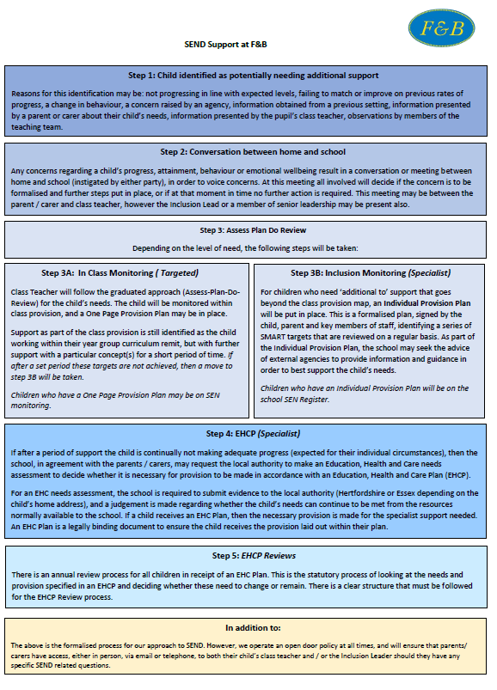
Appendix 1: SEND Support at F&B Flowchart

Appendices
Appendix 2: Whole School Provision Map
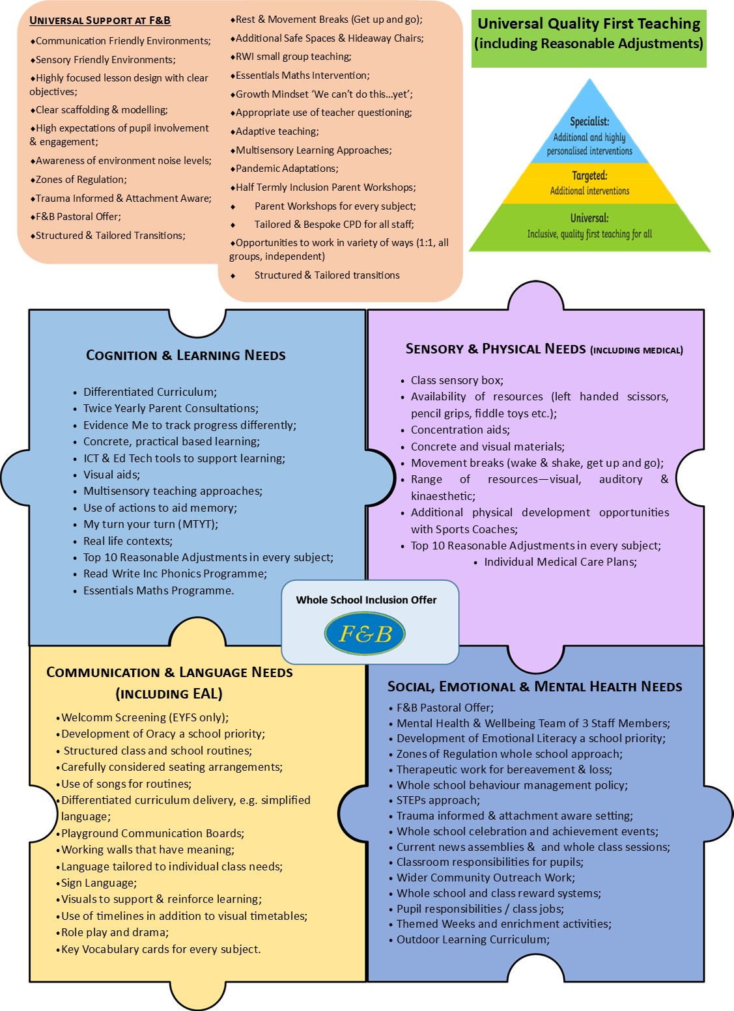

Appendix 2: Whole School Provision Map – cont’d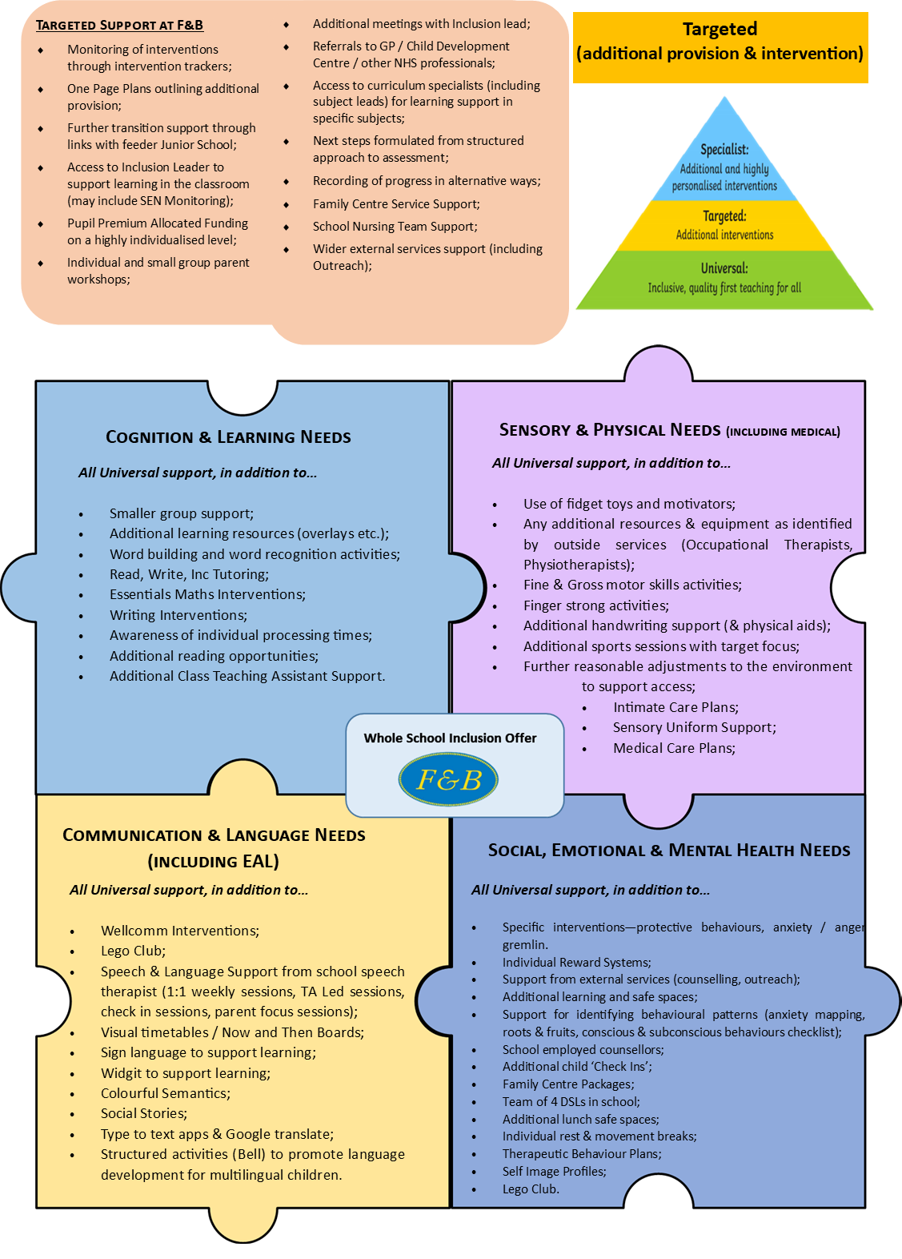

Appendix 2: Whole School Provision Map – cont’d
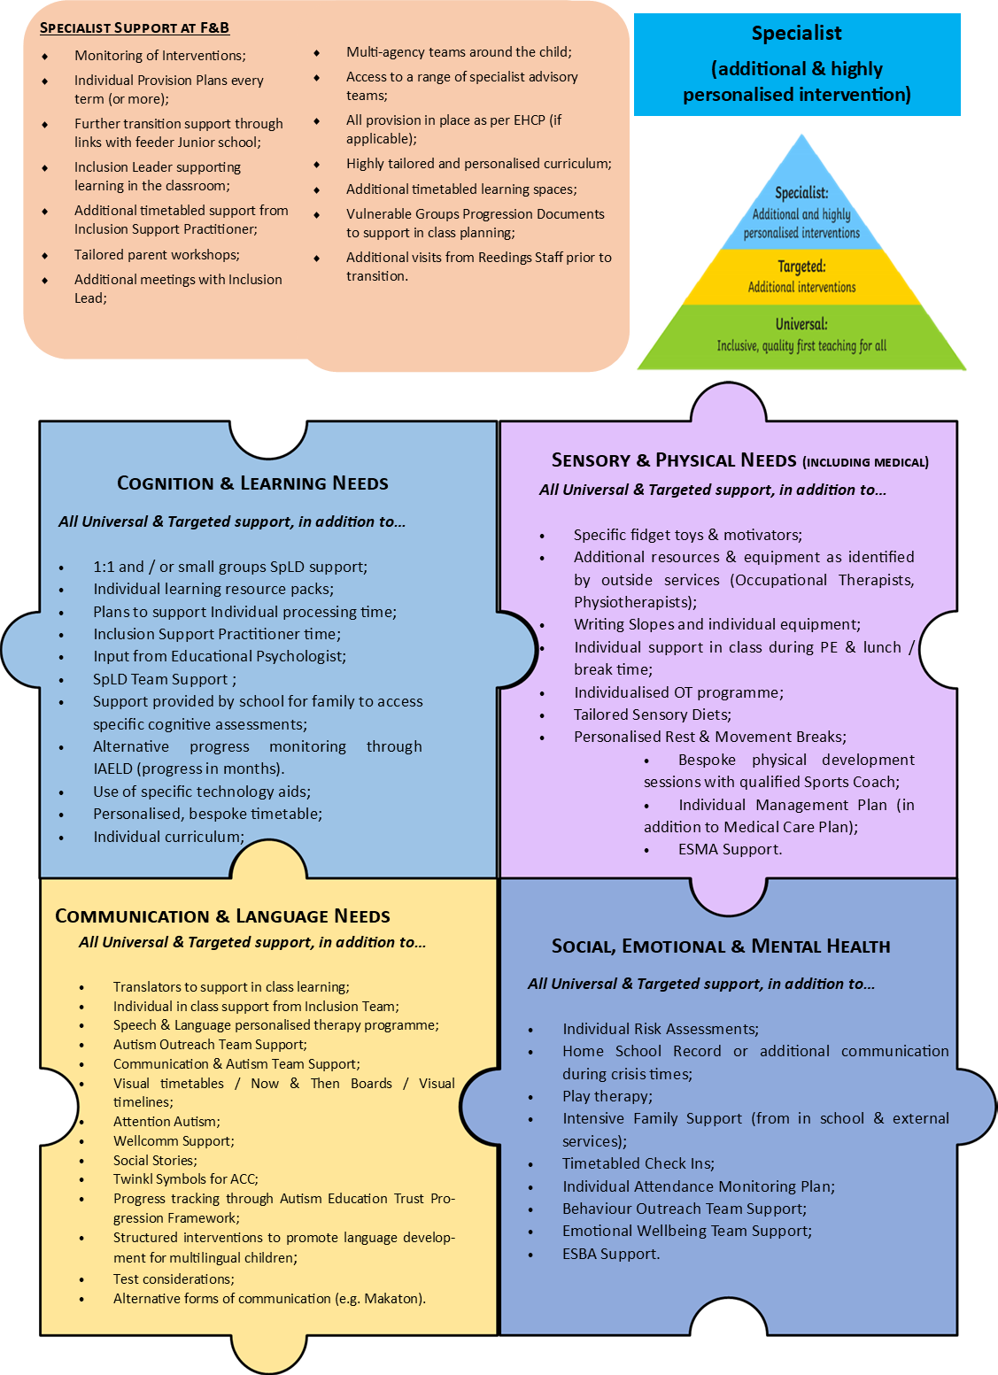

Appendix 3: One Page Provision Plan Template

F&B One Page Provision Plan
Child’s Name: |  | Child’s Class:
Child’s DOB: |  | Primary Area of Need:
Concerns Identified / Reason for Additional Provision:

Provision Offered (include who, ratio, frequency and any key resources)

1) | Name of Provision  Overview of provision.
2) | Name of Provision  Overview of provision.
3) | Name of Provision  Overview of provision.
4) | Name of Provision  Overview of provision.

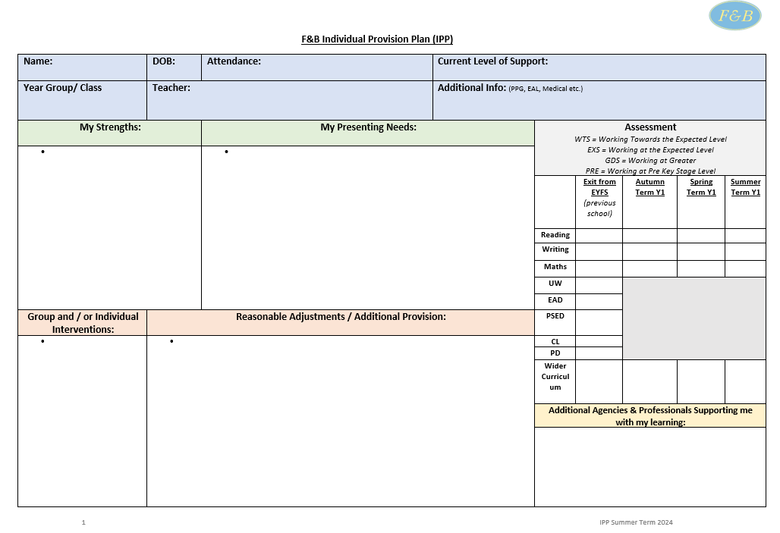
Appendix 4: Individual Provision Plan Template
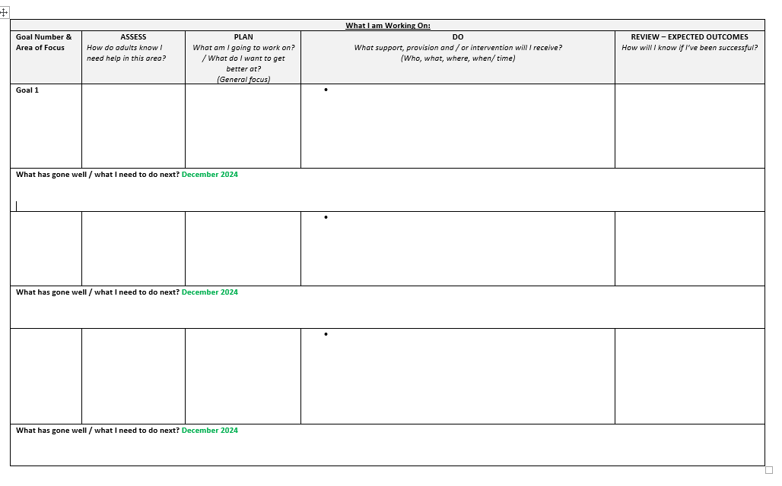

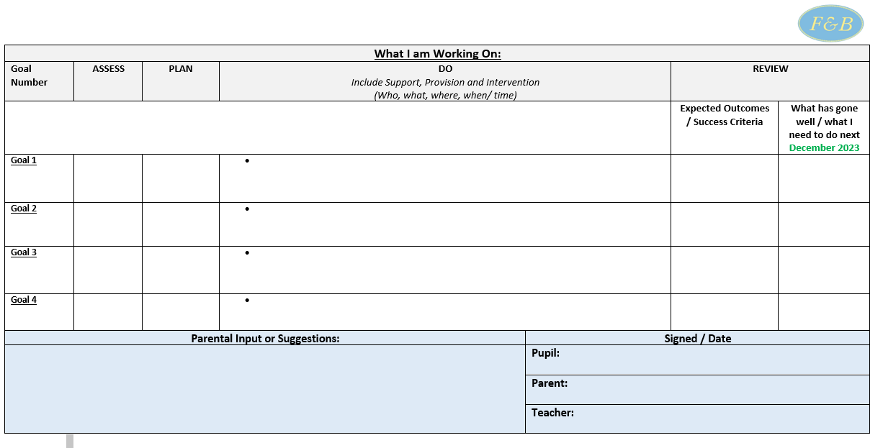
Appendix 4: Individual Provision Plan Template – cont’d

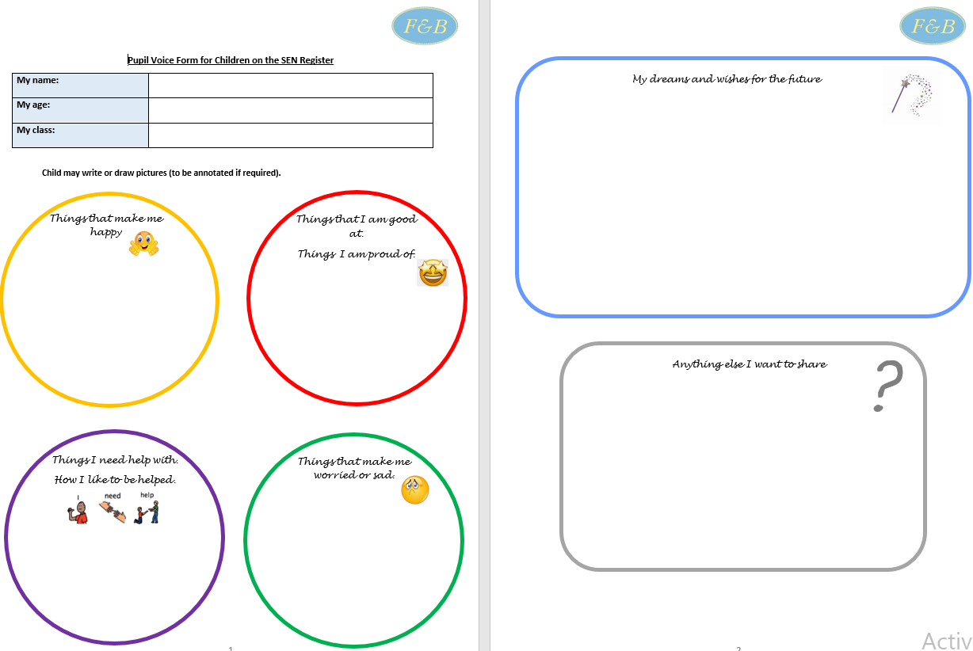
Appendix 5: Example Pupil Voice Temp

